**DESTINATION WEDDING IN INDIA**

Jodhpur:

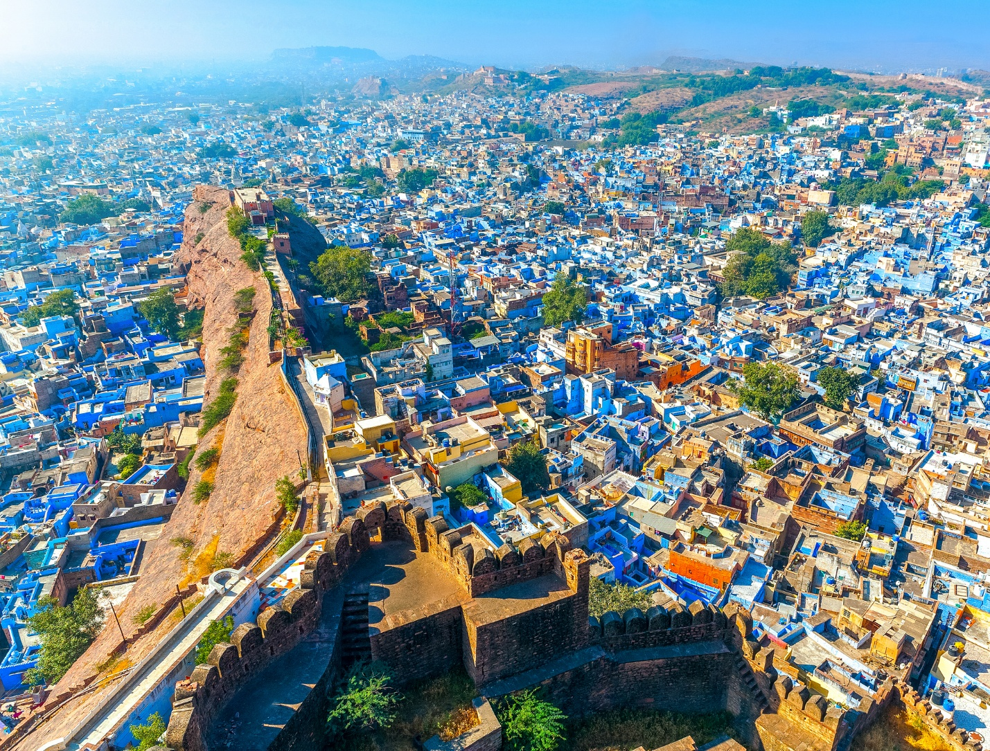

Surrounded by legends that are closer to truth, the fabled city of Jodhpur, bathed in blue, is viewed at its spectacular best from the looming Mehrangarh Fort. Jodhpur is famous for its Mehrangarh fort, blue houses, temples, sweets and snacks. Jodhpur is the second-largest city in the Indian state of Rajasthan and officially the second metropolitan city of the state. Apart from the fort, there are multiple temples, lakes, shopping streets that are like a mirage from a bygone era. Zip line across this medieval fort palace for a quick glimpse of the fort that, legend has it, led to Jodhpur being plagued by drought after a hermit who lived here cursed it. The beautiful white-marble Jaswant Thada, close to the fort, offers stunning sunrises and sunsets so get here early. Rajasthan’s famed ‘Gateway to the Thar’ desert, Jodhpur, is surrounded by a 10-kilometer wall, complete with eight gates around. Begin your morning with a steaming cup of ‘masala chai’ as you walk through small alleys that crisscross town, lined with busy shops selling savory snacks and children running through crowds as the odd scooters honks at a cow on the road. Head over to the clock tower in the heart of the city for a visit to the markets surrounding it, filled with brilliantly colored sales of traditional ware. Umaid Bhavan Palace, here in Jodhpur, is one of the world’s largest private residences; home to the erstwhile royal family, a part of it is now leased to the Taj Hotels. Planning a destination wedding in Jodhpur is no less than a dream for couples. It houses many magnificent places to organize weddings. We have compiled a list of some of its venues here.

* **Umaid Bhawan:**

Jodhpur is the desert capital of Jodhpur. And the Umaid Bhawan Palace is the golden-hued desert sandstone monument in Rajasthan. It is the last of the best palaces of India, and also it is one of the enormous sizes of private residences in the world.

* **Bal Samad Lake Palace.**

Bal Samand Lake Palace, Mandore Road, Jodhpur is away from the hustle of the city life. It is an ideal location for having a destination wedding. The venue serves scrumptious delicacies to choose from in both vegetarian and non-vegetarian food to their guests.

* **Ranbanka Palace – Ratanada**

This grand wedding venue where you can feel the history meeting luxury and luxury meeting with cooking experts and cultural entertainment. To hold a dreamy and regal destination wedding within a budget hotel in Jodhpur, Ranbanka Palace is all you need.

* **Bijolai Palace – Choupasni Road**

Are you floating madap on your wedding day at a lake fascinate for you? This Palace is in Jodhpur is a heritage site in Rajasthan. Bijolai not only provides magnificent facilities but treats you and also your guests feels no less than royalties like a king.

* **Indiana Palace – Shikargarh**

If you’re unsure about booking a palace for your D-day, don’t fret, we have an excellent idea for you to offer you nothing less than a majestic heritage palace. Situated in Shikargarh, Jodhpur, Indiana Palace hotel has a look of a grand castle not only from the outside but interiors as well.

Jaisalmer:

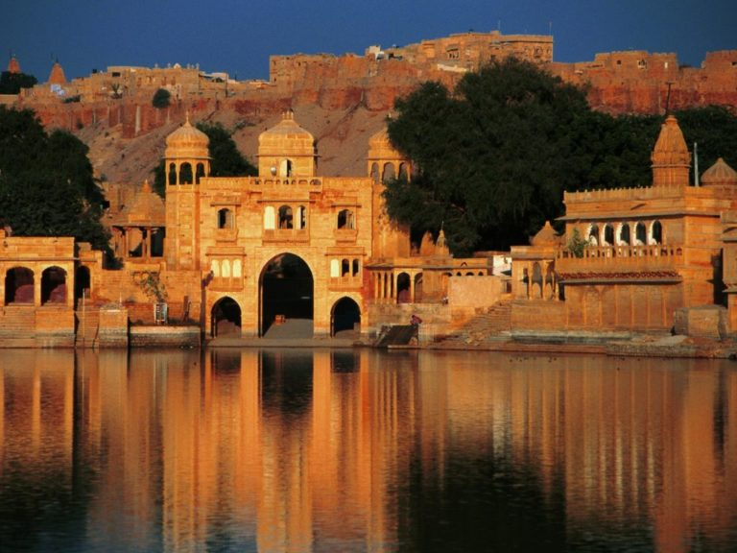

Jaisalmer, nicknamed "The Golden city", is a city in the Indian state of Rajasthan, located in west of the state capital Jaipur. The town stands on a ridge of yellowish sandstone and is crowned by the pad Jaisalmer Fort. Jaisalmer with its royal forts and palaces has the distinction of being the Golden city of India. One of Rajasthan’s biggest tourist destinations, Jaisalmer’s charm, despite the rampant commercialization lies in its massive sand castles, forts, and colorful bazaars. Just below the urban surface, lie the narrow lanes of the old city adorned with elaborate Havelis. For the traveler in you keen on visiting a location with a rich heritage, religious significance, and delicious food, you must explore Jaisalmer.

Named after Maharaja Jaisal Singh, Jaisalmer is one of the most popular historical places not only in Rajasthan but in the entire country. Nestled amidst the wondrous terrain of the vast Thar desert, Jaisalmer makes for a truly mesmerizing sight. Besides picturesque surroundings, Jaisalmer has exciting adventure sports, desert safaris, inimitable hospitality, and delectable cuisines! Jaisalmer has no dearth of things to do and places to eat. This city is blessed with serene surroundings, colorful history, and culture. A shelter of sandcastles and citadels, Jaisalmer is admired for the magnificent Jaisalmer Fort and camel safaris. Not only this, other attractions like Gadi Sagar Lake and Patwa-ki-Haveli and several Jain temples contribute to its popularity as a tourist attraction.

* **Suryagarh**

The perfect venue for an extravagant destination wedding. Suryagarh lies on an outset looking east towards the old city of Jaisalmer and west towards the Thar Desert. Its natural charm provides venues and backdrops straight out of a royal fairy tale.

* **Jaisalmer Marriott Resort & Spa**

If you want to feel royal on your wedding day and forget about all the planning stress, then you’re in the right place. The hotel has 135 rooms with 2 wedding venues. Its staff is professional experienced and friendly, which means, all you’ll have to do is to book their banquet hall, the rest will be taken care of by them.

* **Rang Mahal**

This popular wedding venue has 118 rooms. It is a beautiful garden area that is perfect for hosting that big fat Indian wedding. It has 4 venues which can comfortably accommodate a lavish gathering for haldi, mehndi, sangeet and wedding.

* **Desert Tulip Hotel & Resort**

To host your fairy tale wedding bookmark this venue. It is situated in the heart of the Thar desert. The hotel with 64 rooms complements the terms royalty, heritage, culture, elegance and grace. The hotel has 6 wedding venues.

* **Fort Rajwada**

It is a very famous wedding venue in the entire city. Host your fairytale wedding here. The hotel has 94 rooms with 6 wedding venues. The garden area covers a large part and is most suitable to host an elaborated reception or an engagement party.

Auli

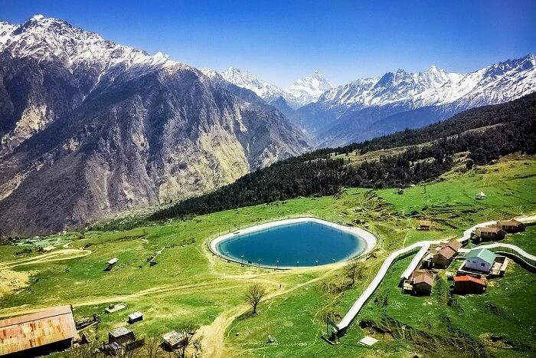

Auli is surrounded by coniferous and oak forests, with a panoramic view of the peaks of the Himalayas. Dotted with the apple orchards, old oaks and pine trees there is no dearth of natural beauty in Auli. Auli is a popular skiing destination in India because of its glittering slopes and clean environment. Dotted with apple orchards, oaks and deodars, Auli is a popular hill town with numerous ski resorts situated amidst the Himalayan range. Located at 2800 meters above sea levels, it is home to mountain ranges of Nanda Devi, Mana Parvat and Kamat Kamet. Many religious destinations are also scattered around Auli. It is believed that Shankracharya had blessed Auli with his visit. Auli is one of the very few places in India where skiing is a major pastime. Gradually Auli is growing like other hill stations in India. The bitter cold winds, the vast snow-covered landscape, the sylvan mountains, all add up to make Auli a skier's paradise. Auli, the former training ground of the Indo-Tibetan Police Force is blessed with salubrious weather, glittering ski slopes encompassed with glossy green trees, apple orchards and scintillating views of colossal Nanda Devi, Hathi Parvat, Mana Parvat, Ghori Parvat, Nar Parvat, Mount Kamet and Mount Dunagiri in the background. Amazing ski resorts and jazzy winter carnival serve as an icing on the cake for this picturesque hilly town. It is everything that one can ask for a perfect winter destination! Whether one is a nature lover seeking rendezvous in the lap of nature or a trekking enthusiastic looking for some fun or honeymoon seekers in search of blissful solitude, Auli is the ultimate escapade for thrill and adventure.

You are a really couple if you are planning a destination wedding in a heavenly place like Auli. The serene hills of Auli recently became the venue for two high-profile weddings of the South Africa-based NRI Gupta family. The ones who crave to be wed among the beauty of the mountains. Then Auli is that the final place to settle on. Who would not need a dream-like wedding celebration, up inside the hills somewhere and far away from the crowd?

Auli any day are going to be the best bet for wedding destination setting throughout an amazing location. Auli, Uttarakhand is known for there amazing ski resorts and rarely natural scenes.

Jim Corbett National Park

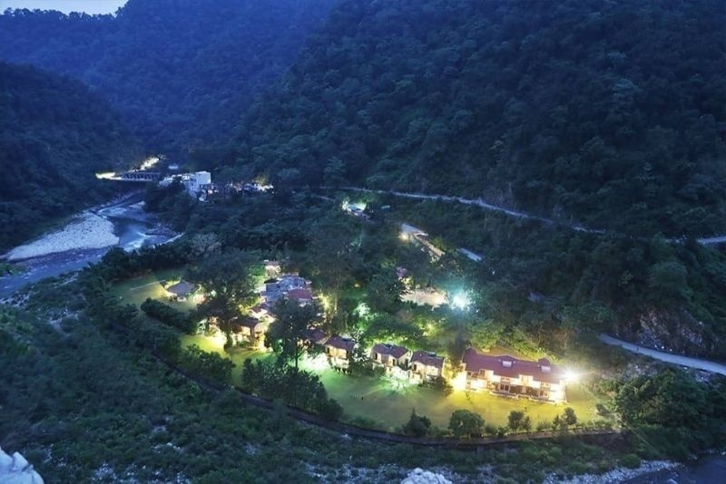

Jim Corbett National Park is the oldest national park in India and was established in 1936 as Hailey National Park to protect the endangered Bengal tiger. It is located in Nainital district and Pauri Garhwal district of Uttarakhand and was named after Jim Corbett, a well known hunter and naturalist. A throbbing getaway to the foothills of the Himalaya into the wild, Corbett National Park, which is located in Uttarakhand along the banks of River Ramganaga, clamps down on several activities like jungle safaris, birding, trekking, fishing, camping and elephant rides. Formerly known to be Jim Corbett National Park, dedicating the legendary British hunter and conservationist Sir Edward James Corbett, the Corbett National Park today is a home to several endangered species including reptiles, mammals and birds. The vast eco sphere that displays a plethora of varied species of plants is an invigorating and natural hub to myriad eco-travelers, adventurers and wildlife photographers. The rich terrain, from the foothills to the plains, is divided into five safari zones that allows travelers to whizz and explore the waylay wild wood.

Many people may not be aware of the fact that it is possible to plan a safe and fabulous wedding there. Below is the list of most famous venues for your wedding in Jim Corbett National Park.

* **Corbett River Creek Resort:**

Corbett River Creek Resort has everything to offer that you have longed for your big day! The soothing forest ambiance and the lush green lawn makes it a unique destination for your wedding. With all the modern amenities offered here, you won’t miss a day of your city life. And wait, keep your camera on selfie mode as you will be clicking a lot of pictures at Ramganga river.

* **The Roar Resort:**

Here’s your chance to make your wedding a one-of-a-kind celebration! As the name suggests, it is very common to hear the roar of a Bengal Tiger at this venue. If lucky, you’ll hear the roar on your big day, too. Don’t worry, The Roar Resort has taken all the safety measures to ensure a safe wedding here. Amidst the silence breaking roar and mind-blowing forest ambiance, it is unbelievable to find such a spectacular venue.

* **WH Corbett Ramganga Resort:**

May your wedding day bloom like an exotic flower with WH Corbett Ramganga Resort. This amazing venue is located at the edge of the mountain and surrounded by a dense forest makes it a real adventure to host your wedding at this place. Your guests will be all satisfied with the modern amenities available at this venue. The in-house decorator will make sure that you have a blast at your poolside wedding ceremony!

* **The Den Corbett:**

May your wedding day bloom like an exotic flower with WH Corbett Ramganga Resort. This amazing venue is located at the edge of the mountain and surrounded by a dense forest makes it a real adventure to host your wedding at this place. Your guests will be all satisfied with the modern amenities available at this venue. The in-house decorator will make sure that you have a blast at your poolside wedding ceremony!

# UDAIPUR – Venice of the East

Just imagine getting married in the middle of lakes, glorified by the stunning sunsets view with a natural brim of music from lakes with sheltered mountains standing to protect your love.

The marvelous city surrounded by aesthetic beauty is one of the most attracted tourists spot set up in the shadows of Aravalli mountains. The royal palaces, majestic forts, amiable nature showered with peaceful rivers and lakes make Udaipur a heavenly abode on earth. Because of the historical popularity along with prestigious culture and marvelous beauty, Udaipur came to be known as Venice of the East. Recently, it was also named as- “The Best Place in the World” by The Travel and Leisure Magazine.”

Capturing precious moments in the beautiful palaces of Udaipur, the magical surroundings provide an amazing ambience makes a truly memorable wedding. The merrily singing of rivers and lakes provides a natural music making the wedding exceptionally fantastic. A sparkling touch of the royal essence makes your wedding a royal glory to be cherished throughout. A popular tradition like- ghoomar dance, kalbeliya and katputtli followed in Udaipur magnifies the ceremony adding glamour to the wedding rituals and celebrations. The city of love provides a romantic weather and a picturesque landscape of a lovely paradise to get married and knit the moments of togetherness.

Exceptionally beautiful venues adorned with the royal glory to have a destination wedding are –

* The Oberoi Udaivilas- Situated on the banks of Lake Pichola, stands a beautiful hotel filled with love and emotions is one of the best venue to conduct wedding at. It’s unique ambience with an option of an indoor as well as outdoor site makes it a popular and the most preferred hotel palace.
* Jagmandir Island Palace- The lush green lawns with magnificent surroundings make the palace versatile and flexible to organize all kind of functions. Its outdoor venue embarks the presence of a blissful wedding. It is often referred as a “garden of heaven” because of its majestic beauty.
* Taj Lake Palace- Known as one of the most romantic hotels of the world stnds to be an ideal location for madly in love couples. It provides elegant hotel rooms along with special suits to knit the perfect moments of togetherness.
* Fatehgarh Udaipur- Located in the middle of the Aravalli hills, lies one of the best wedding resorts in Udaipur, known for its scenic beauty and an amazing view of the mountain top. The lively mountains act as a barrier to all the hatred and throw them down protecting you and your love.
* City Palace- The royal heritage provides a perfect venue to organize a wedding covering the historical courtyards and a rich heritage for a spectacular royal wedding.

Thus, the prestine lake along with the royal hotels, palatial forts and the grandeur of the rulers make Udaipur rich in cultural heritage thus adding a royal beauty to showcase the glory of a memorable destination wedding.

## **MUSSOORIE** – The Queen of Hills

Resting under the shadow of the Himalayas, located in Uttarakhand, lies one of the most popular venue to organize a destination wedding for every mountain lovers. Smiling of peaceful clouds with their love and blessings in the form of raindrops adorned with snow-capped mountains, Mussoorie stands to be a perfect destination. Just imagine the union of pure souls into the bond of love decored with a natural mountainous background and a fascinating atmosphere creating adorable memories to cherish lifelong.

Some of the best venues in Musoorie are-

* **JW Marriott Resort-** A luxurious wedding venue is well known for its elegance and awesome decorations creating a pleasant and an awakening venue where u can perfectly knit your memories and get immersed in love.
* **Royal Orchid Resort**- Not very expensive and an amazing hotel that will take away your eyes by its atmosphere and décor. It adds a sparkle in your wedding thus enhancing the beauty.
* **Jaypee Residency**- Here stands one of the top hotel with a proper wedding preparation and a scenic beauty that makes every moment special. The vibrant colours and beautiful decorations makes you feel on the top of the world.

# JAIPUR- The pink city

Dreaming of a royal wedding can be turned into reality? Yes, a royal and a patronage wedding is very much possible in Jaipur. The architectural beauty, traditional rituals, gorgeous paintings adds a scenic royal background to your wedding. The majestic palaces surrounded by huge mountains would make the ambience exceptionally beautiful.

Some of the best destination places to get married at –

* **Chomu Palace Hotel**- The ancient and the most popular palace has a tradition of Rajputana royalty. Bestowed with the beauty and alliance here stands to be royal venue for a perfect destination wedding.
* **Jaipur Heritage Hotel**- Located in the pink city lies a magical paradise consisting of lush green lawns adding a scenic beauty that will provide a luxurious experience for a grand wedding.

# Agra- The City of Love

Located on the banks of river Yamuna, lies the most romantic and a historical city called Agra. It provides a beautiful atmosphere filled with love all over. Getting married in the city of love is an amazing experience and an awakening dream for every individual. Capturing the moments of togetherness with an epitome of love in the background would be just amazing.

Some of the best places to have a destination wedding at agra are-

* **The Oberoi Amarvilas**- A well renouned resort located near Taj Mahal stands to be a perfect placefor true souls to unite. Moreover, the design and the style of the resort has been inspired by the famous architects of ancient time.
* **The Royal Mansingh Palace**- Located in Fatehabad, stands to be a luxurious grand hotel providing you the best view of the Taj Mahal from its windows bringing a windful love towards your new life
* **The Grand Imperial**- The ancient of all resorts, built in 1900 is a well-known and a very popular venue of destination wedding providing you a Royal experience and a historic legacy of ancient rulers. The lush green courtyard surrounded by ethnic beauty attracts the attention of all viewers. It makes sure to have a grand wedding at a grand hotel with blossoming love all around.

**DESTINATIONS**

# MADURAI:

Modern times may be trendy. But tradition is always unbeatable!

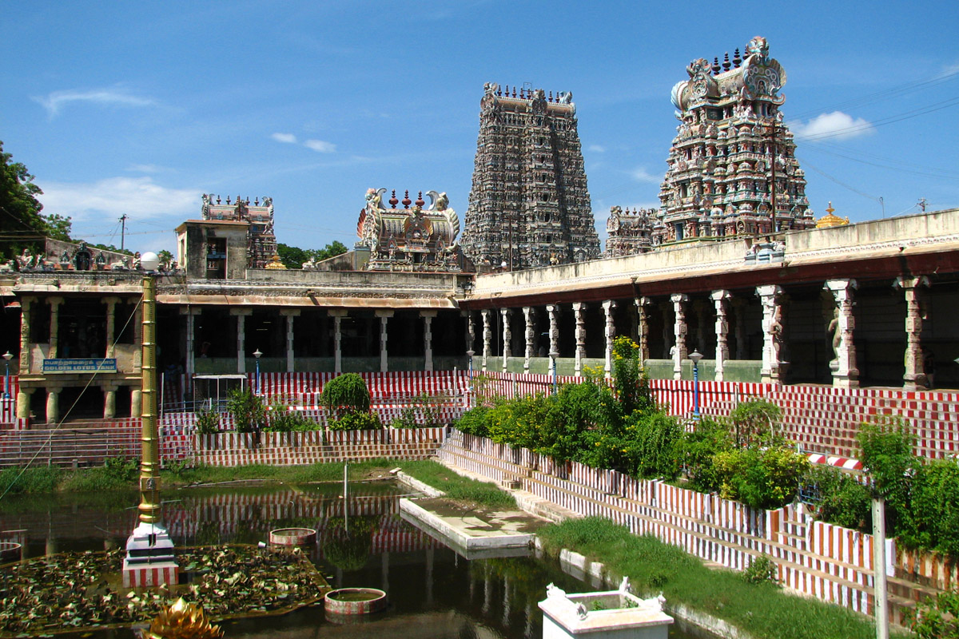

A city of prosperity! The southern bank of Vaigai River will deliver you an experience which will not let your eyes close. The Meenakshi Amman Temple was built on 6th century and still stands on with its name and originality. And so it’s believed that the knots tied there will last as long as the temple lasts there. The Temple City, Madurai is much known for the ancient history. The most elegant striking weddings were held there. It always catches its mark when it comes to tradition. Everywhere you see there is of heritage. The best place for all your needs to get fulfilled! From your pre-wedding till post-wedding shoot, you have no grief on checking out places for backgrounds or lightings. There could be no place with n number of postures as it is. Flowers scent the surrounding. And so women have it and scent the family. Once you enter the Temple City, the pleasurable scent of Jasmine will change all your bad vibes.

The southern food style is always on universal level. Imagine a big banana leaf with hot rice plated first and then some ghee over it with spicy gravy and varieties of vegetable side-dishes. Rasam, curd, payasam and a gulab-jamun are still left over to complete your wedding meal yet. Finally, the famous Jigarthanda (a sweet dessert made out of almond gum and milk) will cherish you with delight! No where your tongue will be treated like this! No day will break this streak! Particularly, varieties of Parotta & Kari Dosa will show you what heaven is! The fried mutton balls of Chettinad style bring a treat to you when served with a pinch of coriander leaf on top. Sea food with Idiyappam is a great treat for all sea food lovers. Cotton seed milk is love!

Madurai is famous for its “kumkumam” also called as “thazampoo kumkumam” and it’s considered very holy for every married women. The prominent bangles of various varieties from Valayalkara Theru will stand unbeatable whatever festival comes and goes. The opportunities are extremely high here. Around 100 wedding halls are waiting for you. You can decide your wish after an overall view. Apart from it, the love that you get all around there is a bliss. The feel which can make you so blessed is positioned there.

# KERALA:

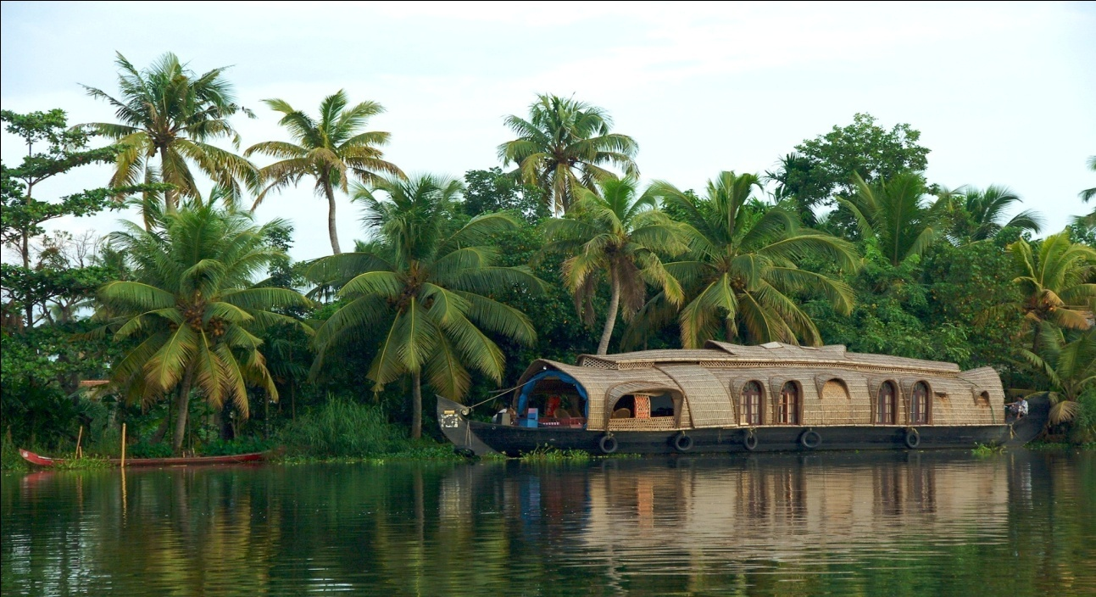

With the Arabian Sea in the West and a channel of backwaters running throughout the state, Kerala indeed offers the most scenic backdrop for all your clicks! And so it’s blessed with the name “God’s own country”. The National geographic had declared it as Paradise of the world amongst ten others. Yes! It is really a paradise, everywhere your eye rotates only greenery remains. With a network of 44 rivers, the state is bliss. The tourism department exclaims that ‘Kerala is an Alfresco state’. Everywhere tall horde of coconut trees will make you feel mesmerized. According to the survey by NSSO, Kerala is said to be the cleanest state of India along with Sikkim. This God’s own country is the first, all time to taste the nature’s first rain fall.

The wealthiest Padmanabhaswamy temple is the known for gold and precious stones. A shocking fact about it is! Kerala has the highest consumption of gold in the county. Such a wealthy state it is! It tries to stand first in all aspects. The only state with highest number of festivals being celebrated is it! Mainly, The Onam- the National festival of Kerala! The Kerala sari itself has its own dignity. It is the world of Ayurveda. Herbs with medicinal properties such as turmeric, Cinnamon, Ashwagandha, Brahmi, Amalaki, Bharangi and Phyllanthus Amarus etc. are found in abundance in Kerala. In short, it is a home to a vast variety of herbs. Kerala share a special bond with elephants in their festivals. The backwaters cover almost half of the length of Kerala. That spicy food remembers it’s another name ‘spice coast of India’. Kerala has its highest peak, Anamudi Peak of Anaimalai range. It shares the border with Idukki and Ernakulam districts.

Kerala is India’s first state with 4 operational international airports; Thiruvananthapuram, Kannur, Kozhikode and Cochin. A best place to go through! Here and there is full of beauty and love. The love you get there will be mark able note on your life’s diary. Its admiring natural effect will take-off your heart and give you back. The boat house of Alappuzha will always bring a floating memory in every clients mind. Once you start being there, then you will start dreaming of building your own boat house and finally realise that ‘we don’t have enough water for it’. That much heart-stealing it is and memorable one too! That is how the God of Nature has showered mercy over it!

# GOA:

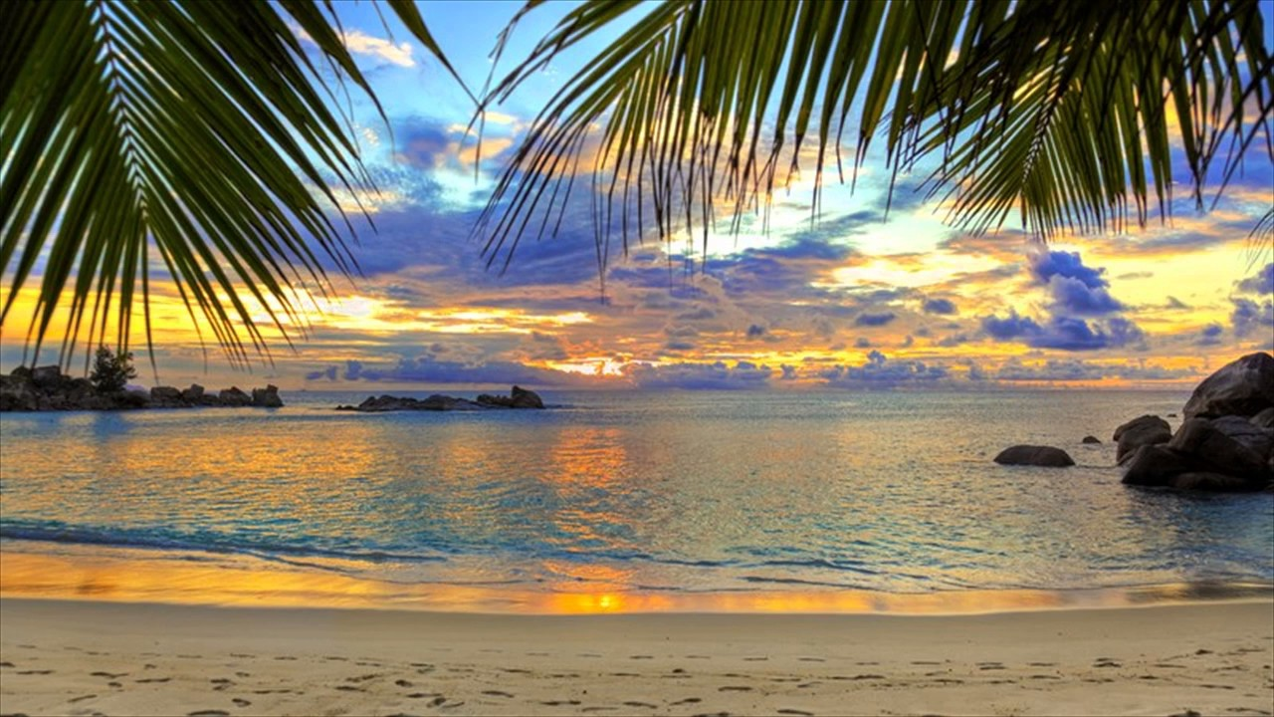

The very first thing about Goa is the ‘beaches’. On the north, the picks are usually Baga, Candolim, Anjuna and Vagator, while the south boasts Palolem, Agonda and Utorda. Beach always stores memories. Memories of joy, memories of loneliness, memories of love, and memories of childhood and so on are hidden deep inside. The feeling of sitting in the same place where you have sat on your times of sadness is always different one to heart. Similarly, a destiny wedding on the banks of beaches is bliss. It had been a great dream for many couple and been fulfilled by Humsafar. We serve her to make out with all your dreams. Every February, Goa comes alive to celebrate the carnival. A festival that dates back to the Portuguese era, it is celebrated with great pomp throughout the state, with the Catholic community leading the charge. Across the city and villages, you will see people dressed in traditional clothing or even fancy dress, with good food and alcohol making it a party! The streets show colours on February. Goa have been ruled by the Portugues till 1961 and so it has many churches. When Christian festivals come, the people show much energy over here and there. There are more famous beaches all over world, but still Goa has its own individuality. Do you know why? It is because most popular beaches in Goa offer the opportunity to go paragliding, parasailing, banana boat riding and snorkeling.  On some beaches, you can even go scuba diving.  On some beaches, you can even go scuba diving. These restaurants serve a mix of traditional and continental food and plenty of alcohol. Basically, Goa is a place known for a friend’s trip because of the low tax for alcohol available there. The influence of Portuguese can be seen everywhere even now in the city, particularly Panjim and Altinho, where much of the Goan government resides. Aside from this, even the houses in the villages and the churches show off a particularly Portuguese side. Many of the old-timers continue to speak the language. It is a place with friendly campus. Will there be anyone who is not interested in Dolphin spotting? Never! Everyone loves it and its available in Goa for cheap. You are allowed to take a banana boat and start your drive inside the limited places of Ocean. Within few depths, you can see dolphins coming around you to cheer you up and then, they start coming in groups and enjoy the day with you. Goa is a tiny state with a lot of greenery. This means that it has a lot of wildlife sanctuaries, such as Bondla, Cotigao and Netravali wildlife sanctuaries. Every side you see offers you fun and entertainment. More than a friend’s trip or family tour, its much suited place for a destination wedding, this is a dream of many!

# ANDAMAN AND NICOBAR ISLANDS:

The turquoise waters speak!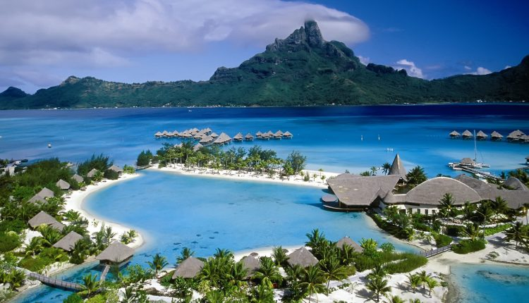

Ever noticed the scenery on a 20 Rupee note? The image of a picturesque bay lined with lush greenery captured on the red-coloured note is the North Bay Island and the same view can be seen on the way to Mount Harriet. Mount Harriet is the second highest peak in the Andaman and Nicobar archipelago. That is how famous the greenery is about here! The onlyactive volcano in Barren Island and the mug volcano in Baratang are present there. TheRoss Island is one of the ancient buildings of rocks which stood best for its elegance. Therearetwo beautiful waterfalls on the Little Andaman island – the White Surf waterfall which is6.5 km from Hut Bay Jetty and the Whisper Wave, which is 20 km from the same. One can take an elephant safari or trek through the verdant forests of the island to reach the pristine waterfalls. The location of the Andaman and Nicobar Islands straddles one of the most critical naval and trade choke points in the world. Andaman and Nicobar Island has India’s first and only joint tri-service defence command and so it’s a secured place to enjoy with. All destinations are at the peak of greatness! Radhanagar beach is a best beauty spreader over there. It is located 12km from Havelock Island. The evening shine of sun over there marks a best backdrop for photo lovers. There are also many other beach such as Elephant beach, Vijaynagar beach and Kalapathar beach. The breeze of beach is lovely and memorisable!

Neil Island! The coral reefs and white shores speak about. The mornings are perfect timings to watch the coral carves. All who love snorkelling will enjoy this coral capital of Andaman.

If you are a person who love enjoying the nature and wildlife, don’t forget to visit this. The Great Nicobar Islands! The core attraction of it is the Great Nicobar Biosphere Reserve and the Indira Point. All the tourist places of Andaman and Nicobar Island is best known for peace and silence. Destination weddings done here are nearly equal to the weddings done on Paradise. It give a feel of starting something with peace all over. Although it has its own language called Andamanese, the most commonly spoken language among there are Bengali, Tamil, Hindi, Telugu and Malayalam. It’s a friendly place to move with! And a place to find what you are!

## 